Ammeter Report

# Introduction

The main goal of this experiment has been to measure the output signal of a Trans Impedance Amplifier (TIA) wired to a current source. <more information: why are we testing this, what assumptions have you made, what ranges are we interested in? what are all the options for these ranges?>

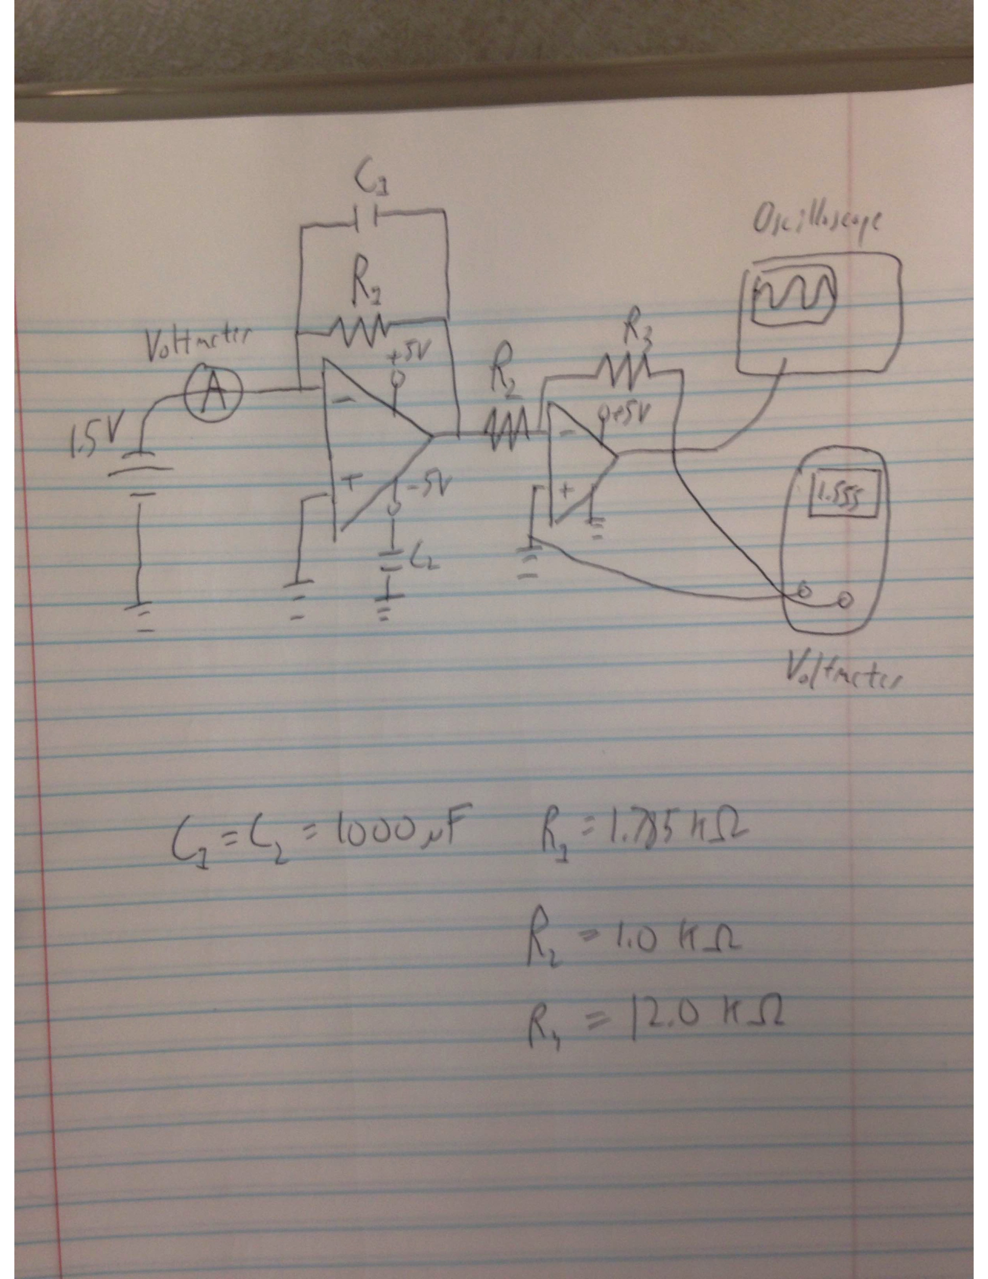

Figure 1: Schematic of the Trans Impedance Amplifier (TIA) with subsequent inverter.

# Setup and Test Cases

The general layout of the circuit is shown in Figure 1.

<restructure and reformat this, explain the parts of the circuit, put all the values in the table instead of the text.>

In this case the current source consisted of a 1.5 V battery connected to a potentiometer that allowed for a wide range of current values. Two different feedback resistors for the TIA were implemented, a 21.9 resistor for a gain 1000 amplifier and a 1.788 k resistor for a gain 10 amplifier. A 1000 F feedback capacitor was also incorporated into the TIA as well as another 1000 F capacitor which was grounded in order to eliminate noise from the 5V power source.

By conducting measurements using the gain 1000 amplifier it was found that a low feedback resistor corresponds to a very large amount of noise in the range of hundreds of millivolts. Thus it was determined that future measurements using the ammeter should only be done using large feedback resistors with low gain amplification.

Table : Resistor and Capacitor values for the different test cases.

|  |  |  |
| --- | --- | --- |
| Element | Case 1 | Case 2 |
| R1 | 21.9 Ω | 1.788 kΩ |
| R2 |  |  |
| R3 |  |  |
| etc…. |  |  |

# Measurements

<brief explanation>

## Case 1

<put everything pertinent to case 1 (21.9 Ohm) here. Table with values, figure, etc.>

## Case 2

<put everything pertinent to case 2 (1.788 kOhm) here. Table with values, figure, etc.>

|  |  |  |  |  |  |
| --- | --- | --- | --- | --- | --- |
| I(microamps) | V(output) | V(expected) | V(ripple) | Output Error | V(expected)-V(output) |
| 25.6 | 0.549 | 0.553 | 0.002 | 0.00052 | 0.004 |
| 31 | 0.662 | 0.67 | 0.0075 | 0.000586 | 0.008 |
| 39.5 | 0.848 | 0.865 | 0.01 | 0.000688 | 0.017 |
| 46.8 | 1.01 | 1.027 | 0.0066 | 0.000776 | 0.017 |
| 53.7 | 1.156 | 1.176 | 0.0056 | 0.000859 | 0.02 |
| 67 | 1.465 | 1.467 | 0.0041 | 0.00102 | 0.002 |
| 68.3 | 1.472 | 1.475 | 0.0055 | 0.00103 | 0.003 |
| 79.8 | 1.722 | 1.724 | 0.0045 | 0.00172 | 0.002 |
| 89.4 | 1.933 | 1.931 | 0.0033 | 0.00128 | 0.002 |
| 93.1 | 2.013 | 2.011 | 0.0044 | 0.00133 | 0.002 |
| 98.5 | 2.126 | 2.128 | 0.0047 | 0.001163 | 0.002 |
| 111.1 | 2.401 | 2.399 | 0.0051 | 0.00155 | 0.002 |
| 119.9 | 2.599 | 2.59 | 0.0067 | 0.00122 | 0.009 |
| 123.9 | 2.683 | 2.676 | 0.0035 | 0.00132 | 0.007 |
| 135.6 | 2.918 | 2.929 | 0.013 | 0.00143 | 0.009 |
| 148.3 | 3.215 | 3.203 | 0.0088 | 0.00155 | 0.012 |
| 158.1 | 3.435 | 3.415 | 0.011 | 0.00176 | 0.03 |
| 167.5 | 3.687 | 3.618 | 0.0061 | 0.0019 | 0.069 |
| 177.4 |  | 3.831 | 0.0072 | 0.0201 | 0 |
| 185.6 |  | 3.831 | 0.0054 | 0.00222 | 0 |
| 196.9 |  | 3.831 | 0.003 | 0.00258 | 0 |

For this case of a 1.785 feedback resistor the data measured included the input current, the output voltage as well as the ripple voltage measured using the oscilloscope. Additional values were the expected output voltage, the difference between expected and output voltages and the error in the expected voltage. The error in the expected voltage was found using Ohm’s law and the intrinsic error in the input current and the resistors. In this case the error in the current was constant at 0.01 A and the error in the resistors was also constant at 0.001 k.

After finding the error values for the expected voltage it was possible to add error bars on the graphs in Excel for all the data series that are tabulated above. Using the Custom error option and the Errors data it was possible to add in bars for each data point in the expected output voltage error series.

Table 3. Constant error values

|  |  |  |  |
| --- | --- | --- | --- |
|  | Output Voltage | Input Current | Resistors |
| Error | 0.01 V | 0.01 | 0.001 k |

Figure 4. Table of 21.9 ohm feedback data

|  |  |  |  |  |  |
| --- | --- | --- | --- | --- | --- |
| I(microamps) | V(ripple)  (Volts) | V(Output)  (Volts) | V(expected)  (Volts) | V(output)-V(expected)  (Volts) | Expected Voltage Error |
| 46.9 | 0.23 | 1.416 | 1.027 | 0.389 | 0.000776 |
| 68.3 | 0.513 | 1.845 | 1.496 | 0.349 | 0.00111 |
| 75.6 | 0.411 | 0.856 | 1.656 | 0.8 | 0.00168 |
| 111.6 | 0.354 | 1.999 | 2.444 | 0.445 | 0.00154 |

# Conclusion

For future work on the ammeter it has been posited that for current values in the 0-200 mA range measuring an output voltage should be done using shunt resistors. The reason for this is due to the high level of noise present in using a low feedback resistor as shown in the data for a 21.9 resistor. For the maximum current of 200 mA in order to achieve a maximum voltage of 3.747 V a shunt resistor of 18.74 should be used which will give a corresponding power of 0.749 W.